Bus Boys Tutorial Manual

1. Customer Manual
2. Employee Manual

**Customer Manual: Viewing bus routes**

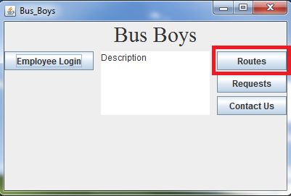

To view bus routes, click the “Routes” button from the home screen. A popup window will appear which displays current route info.

**Customer Manual: Requesting a taxi:**

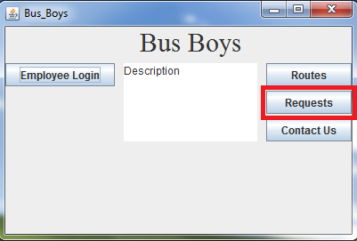

First, click the “Requests” button to go to the requests page.

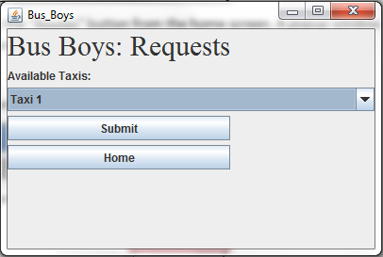

Next, select a taxi from the drop-down list. Click “submit” to submit your taxi request.

**Customer Manual: Contacting Us**

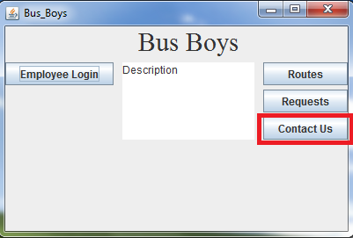

First, click the “Contact Us” button from the home page. This will take you to the contact us page.

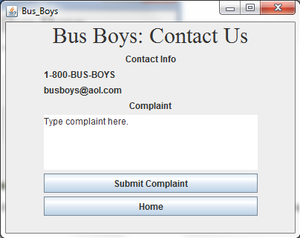

Contact phone number and email address can be found in the contact info section. To submit a complaint, type a complaint into the complaint box and then click the “Submit Complaint” button to submit your complaint.

**Employee Manual: Logging In as an Employee**

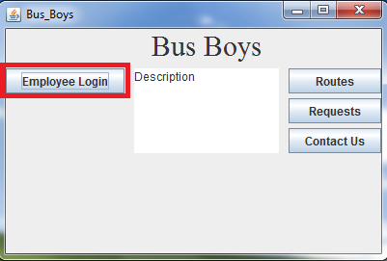

First, click the “Employee Login” button from the home page. This will take you to the login page.

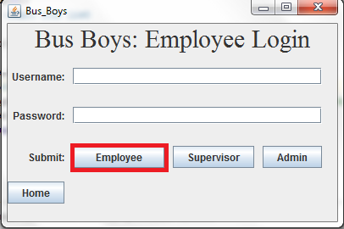

Enter your Username and Password in the indicated fields and then click “Employee” from the Submit bar to authenticate your credentials. If they are correct, a popup window will display your current employee info.

**Employee Manual: Logging In as a Supervisor**

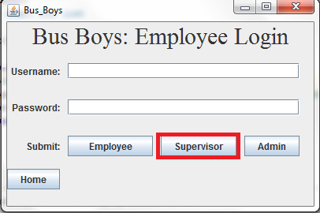

From the login page, enter your Username and Password and click “Supervisor” from the submit bar to authenticate your credentials. If they are correct, this will take you to the supervisor page.

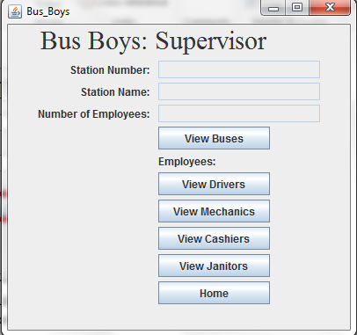

From this page, your station number, station name, and number of employee supervised will be displayed in the indicated fields. You can view busses at your station by clicking the “View Buses” button, which will display a popup window with bus info. You can also view information about specific types of employees that you supervise by clicking the respective buttons. Popup windows will display information about each category.

**Employee Manual: Logging In as an Admin**

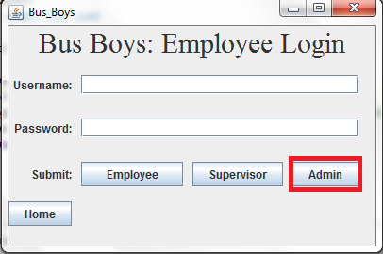

From the login screen, enter your Username and Password in the indicated fields, then click the “Admin” button on the submit bar to authenticate your credentials. If they are correct, this will take you to the admin page, where you can access additional administrative functionality.

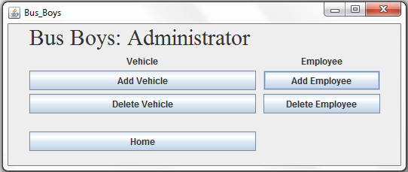

From this page, you can add a vehicle by clicking the “Add Vehicle” button, delete a vehicle by clicking the “Delete Vehicle” button, add an employee by clicking the “Add Employee” button, and delete and employee by clicking the “Delete Employee” button. By clicking any of these buttons, a popup window will be displayed which guides you through the functionality of the process.